Project 1
Precast Prestressed Beam
Assignment 2

CEE 530
Prestressed Concrete
Due 3/2/2026

Group 3
Hailey Crosson
Reyaneh Kazemian
Leohuns Robert Kambu
Prince Aminu
Chidchanok Pleesudjai (Fen)
Haribhushan Sirigineedi

Project 1 - Part 2 - Feasibility Chart
Problem Statement:
(1) Draw the feasibility domain at 0′, 10′, 20′ and 32′ from the left support.
(2) Compute the required prestressing force, assuming 15% losses.

Given

Material Properties and Allowable Stresses
f′_{c} = 6 ksi, f′_{ci} = 4.8 ksi, f_{pu} = 270 ksi

concrete unit weight = 150 lb/ft³ = 0.0868 lb/in³

Section Properties
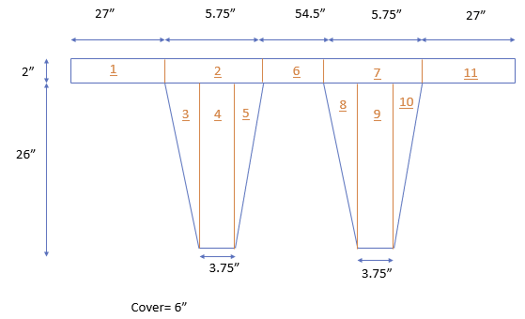
Figure 1. Section dimension

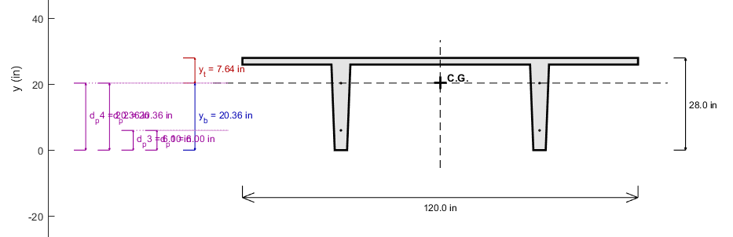
Figure 2. Section dimension at the support

Calculating Stresses (From Project 1-Part 1)

Eccentricity
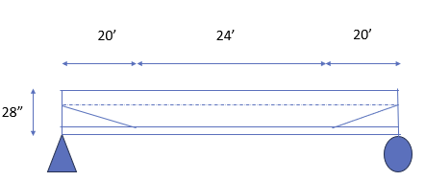
Equation for the eccentricity of draped cable from 0 to 20 ft: e₁ = (14.36/20)x
@ 0 ft: e₁ = 0 in, e₂ = 14.36 in
@ 10 ft: e₁ = 7.18 in, e₂ = 14.36 in
@ 20 ft: e₁ = 14.36 in, e₂ = 14.36 in
@ 32 ft (midspan): e₁ = 14.36 in, e₂ = 14.36 in

Moment Due to Self-Weight and Live Load (From Part 1)

- Dead load (self-weight) = 0.0868 lb/in³ × 487 in² = 42.27 lb/in = 507 lb/ft

- Sustained dead load (2″ concrete topping)
= 0.0868 × 2 × 120 = 20.83 lb/in = 250 lb/ft

- Live load = 420 lb/ft

Moment equation: M(x) = 0.5wLx − 0.5wx²

Material Properties and Allowable Stresses
f′_{c} = 6 ksi, f′_{ci} = 4.8 ksi, f_{pu} = 270 ksi

Allowable stress

transfer:
f_{c} = 0.6 f′_{ci} = 0.6 × 4.8 = −2.88 ksi (−2,880 psi)
f_{t} = 3√(f′_{ci}) = 3√4800 = +207.85 psi (+0.208 ksi)

service:
f_{c} = 0.6 f′_{c} = 0.6 × 6 = −3.6 ksi (−3,600 psi)
f_{t} = 6√(f′_{c}) = 6√6000 = +465 psi (+0.465 ksi)

Calculate the moment at each location condition

Transfer

Service

Stress at bottom and top

Transfer stress

Service Stress

Calculating the constant value
yt, yb = distances of upper and lower edges, respectively, from CGC
yt =−(h − yg) = −7.64 in
yb = (yg) = 20.36 in
kt, kb = distances of upper and lower kern points, respectively, from CGC
St := MOI / yt = −4535.08 in³
Sb := MOI / yb = 1701.15 in³
kt := Sb / A = 3.49 in
kb := St / A = −9.31 in

Section 1, @ 0 ft from the left support, Lx = 0

Moment min

Moment max

Transfer stress

Service Stress

At 0 ft: e₁ = 0 in and e₂ = 14.36 in

Therefore, the

From Figure 3, the possible range of 1/P is

At Lx = 0,
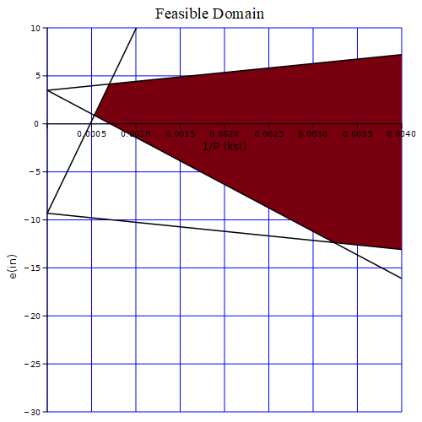
e_eff = -2.18in
Figure 3

Section 2, @ 10 ft from the left support, Lx = 10ft

Moment min

Moment max

Transfer stress

Service Stress

At 0 ft: e₁ = 7.18 in and e₂ = 14.36 in

Therefore, the

From Figure 4, the possible range of 1/P is

At Lx = 10,

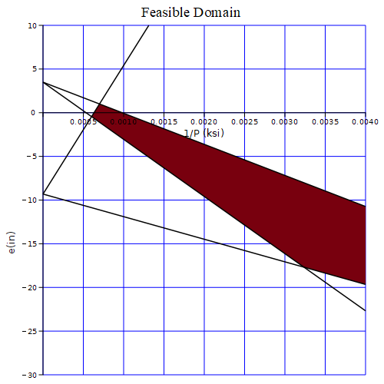
e_eff = -10.77in

Figure4

Section 3, @ 20 ft from the left support, Lx = 20ft

Moment min

Moment max

Transfer stress

Service Stress

At 0 ft: e₁ = 14.36 in and e₂ = 14.36 in

Therefore, the

From Figure 5, the possible range of 1/P is

At Lx = 20,
e_eff = -10.77in

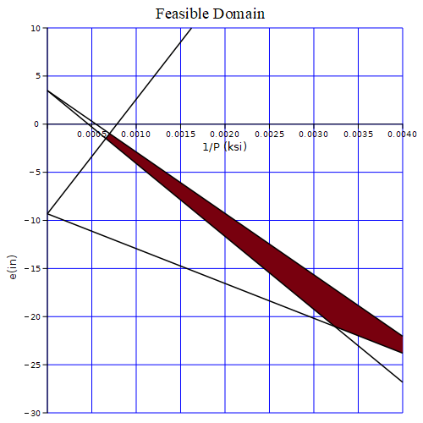
e_eff = -14.36in

Figure 5

Section 4, @ 32 ft from the left support, Lx = 32ft

Moment min

Moment max

Transfer stress

Service Stress

At 0 ft: e₁ = 14.36 in and e₂ = 14.36 in

Therefore, the

From Figure 6, the possible range of 1/P is

At Lx = 32,
e_eff = -10.77in

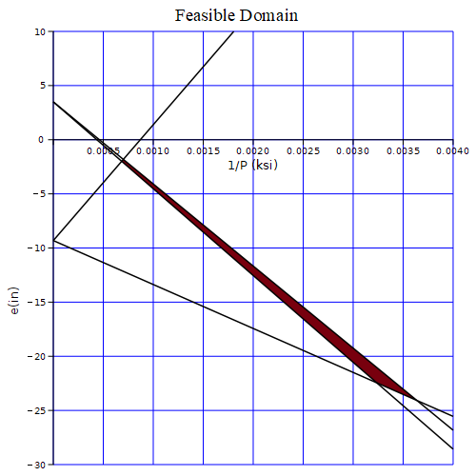
e_eff = -14.36in
Figure 6

Conclusion

At Lx = 0,
At Lx = 10,
At Lx = 20,
At Lx = 32,

From the feasibility analysis at the four locations, the maximum value of $\frac{1}{P}$ that governs all criteria is:
$${\frac{1}{P}}_{\text{max}}=0.0023$$
Therefore, the maximum allowable prestressing force is:
$$P_{\text{max}}=\frac{1}{0.0023}=434.78\text{ kip}$$

